Grafham Annual Parish Assembly May 2026 – Appendix: C

Grafham Church
Our two monthly services have been well attended and we have been delighted to regularly see our friends from Brampton and Ellington at these. Candle-lit Taize services have continued on second Sundays in the evenings and attract regular attenders.

During Lent we have once again met weekly in the Village Hall to take part in periods of reflection on bible passages and discussion. These have been followed by delicious home made soups and bread. Cash donations have been given to Christian Aid. Messy church on Good Friday attracted a large number of children and families. There were various craft activities including making Easter gardens and these were followed by a talk and a lunch including mini hot cross buns. It is a very popular annual event and we owe many thanks to all the volunteers who make this happen. On Easter day there was no service at Grafham but in the afternoon Open Church offered tea and cake, traditional music and a pleasant opportunity for families to come into church to see the flower arrangements, the Easter garden and meet friends.
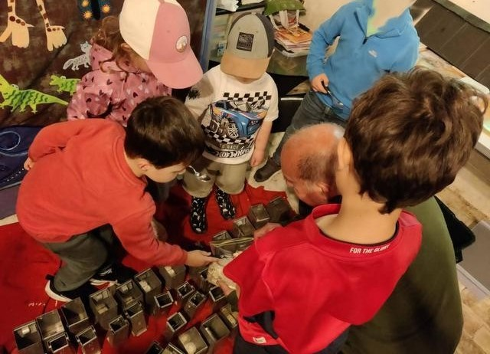
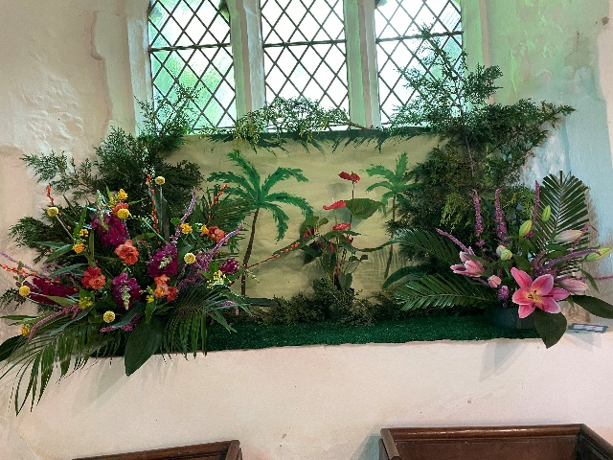

Our Flower Festival theme was Films and the depiction of those was pretty amazing, the photos from which filled two whole pages of Grafham Gossip, our village newsletter. The Bioblitz which runs concurrently with the Flower Festival was popular with a large group of children, being informative, educational and enjoyable. Tea and cakes served on both afternoons was hugely appreciated by our visitors.

The Harvest lunch which Grafham has held for many years was attended by over 20 people. As usual there was a delicious array of dishes plus wine and soft drinks. Harvest Songs of Praise in the church followed and donations of food were brought for delivery to Godmanchester Foodbank. On 11th October our Fellowship Impact group hosted a Supper Night in the Village Hall. Various hot pots were served with accompanying jacket potatoes, couscous, salads and bread. Traybakes were served afterwards. Diners were very appreciative of the food prepared and we owe thanks to the Fellowship volunteers for their efforts to provide this very pleasant and sociable evening.

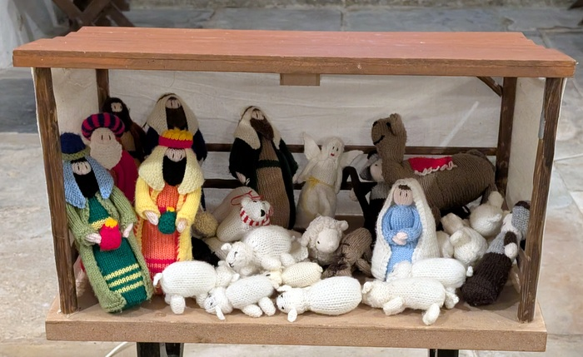
This year there were two Christmas trees to decorate, an extra one having been donated
by a villager. Our first December service celebrated Christmas Giving with donations of extra special festive treats for Godmanchester foodbank to help those families struggling with the extra costs of providing traditional treats at Christmas.

Curry and Carols at the Cinnamon was well attended as usual, and the restaurant was
packed to capacity to enjoy this jolly evening. Our choir excelled themselves at our Carol service giving us some glorious musical moments. The Christmas cake and
mulled wine were well received after all our lusty singing. Our Crib service on Christmas eve attracted at least three generations of families and it is a joy to know that children are being encouraged to come and hear the true story of Christmas. On Christmas day at our Holy Communion service Christmas gifts were the subject of our sermon as some lucky congregants had been opening them before the service.

We are indebted to those silent volunteers that throughout the year clean our church, provide flowers to make the church welcoming for visitors and make tea, coffee and cakes for our first Sunday services. Also, the team of mowers who keep our churchyard tidy and the workshop volunteers who care for the wilder areas. Thank you all.
Hazel Powell

