Parish Council Update – March 2026

Food Waste Collection
Food waste caddies are on their way from 12th January, with weekly collections starting from 30th March. Food waste collection is set out in national legislation and not just a local decision. Councils across England are legally required to collect food waste separately from all households and businesses. The aim is to make recycling easier, more consistent, and available to everyone, no matter where they live.

So far, 37,000 households have had their caddies delived, in preparation for the rollout of the new food waste collection service from 30th March. All food caddies should be delivered by 28 March.
For more information, please visit: https://www.huntingdonshire.gov.uk/bins-waste/food-waste/

Public consultation opens on Local Government Reorganisation in Cambridgeshire
The government’s public consultation on Local Government Reorganisation (LGR) in Cambridgeshire and Peterborough is now open.

The consultation is an opportunity to have your say on the options put forward for LGR in Cambridgeshire and Peterborough. Please respond by 23:59 on Thursday 26 March 2026.

The government will make the final decision on which option is selected and it is expected they will announce the outcome in the summer.
You can find further information on LGR and the options put forward on the Local Government Reorganisation page. https://www.huntingdonshire.gov.uk/council-democracy/meetings-and-decision-making/local-government-reorganisation/

The consultation will run until 26 March 2026 and residents can share their views online at: https://consult.communities.gov.uk/local-government-reorganisation/cambridgeshire-and-peterborough/

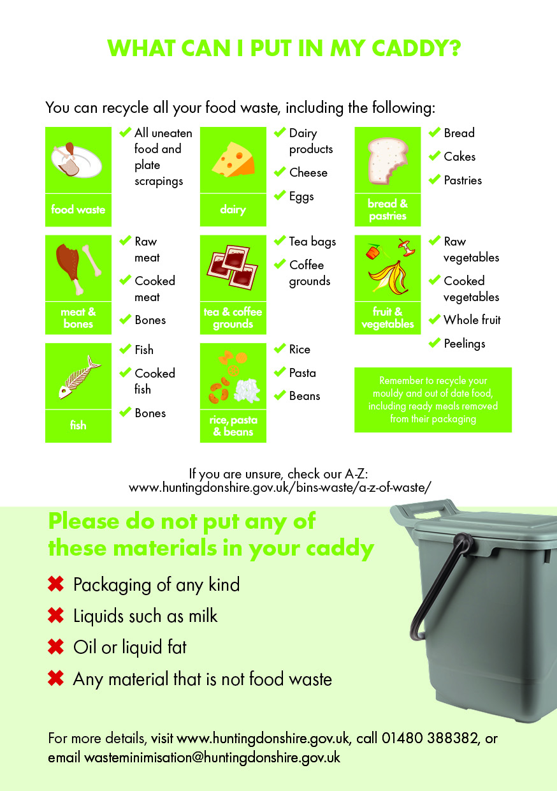

Local Plan to 2046 Update: Preferred Options Consultation
The Preferred Options Draft Local Plan to 2046 consultation closed on 17 December 2025. Comments received from stakeholders and statutory consultees will be processed, and reviewed and further technical evidence will be gathered to inform the Proposed Submission Local Plan
HDC anticipates consulting on this in summer 2026 - For more information, please see our updated webpages. You can view the responses to our Preferred Options draft Local Plan to 2046 and Sustainability Appraisal on our online consultation portal.

